

PO Box 465

Itasca, IL 60143-0465

Phone: (630) 766-0505 x8

THE KIDS EQUIPMENT NETWORK APPLICATION

DATE: _____________

REFERRAL SOURCE INFORMATION:

Name: ______________________________ Address: ________________________________

Agency: ______________________________ Email: ________________________________

Relationship to applicant: _________________ Phone: ________________________________

APPLICANT INFORMATION:

Child’s name: ____________________________ Gender: Male / Female

Date of Birth: ____________ Age: ___________

Phone: ____________________________ Alternate phone: _______________________

Address: ____________________________ Email address: _______________________

City: ____________________________ State: ________________

County: ____________________________ Zip: ________________

Diagnosis / Disabling condition: ____________________________________________________________

Mother’s name: ______________________________________________________

Father’s name: ______________________________________________________

Health coverage: ☐ Private Insurance (Company): _____________________, ☐ Medicaid

☐ Medicaid Managed Care: ____________ ☐ Other:_____________________________, ☐ None

EQUIPMENT REQUEST:

Check box: Manual wheelchair: ☐ self-propel ☐ propelled by others ☐ tilt in space ☐tie downs

☐ Power wheelchair: functions needed _____________________________________________________

☐ Adaptive stroller ☐ Walker: type _________________ ☐ Gait trainer

☐ Crutches: type ______________ ☐ Stander ☐ Bath/Shower chair ☐ Adaptive toilet system

☐ Specialized car seat ☐ Other: _________________________________

Weight:_______________pounds Height:____________inches

NOTE: For ambulatory aids (e.g. walker, crutches, gait trainer, etc.) please provide floor-to-wrist height while standing: __________ inches. ☐ Not applicable

NOTE: For seating devices (e.g. wheelchairs, etc.) please complete the sizing chart on page 2. ☐ Not applicable

Statement of how equipment will benefit child:____________________________________________________

__________________________________________________________________________________________

__________________________________________________________________________________________

Has funding been previously requested: please list source(s): _________________________________________

If yes, please provide the current status of your request (e.g. in review, denied): _________________________

If this was denied by funding, has it been appealed? ☐ yes date of appeal________ ☐ no

THE KIDS EQUIPMENT NETWORK APPLICATION

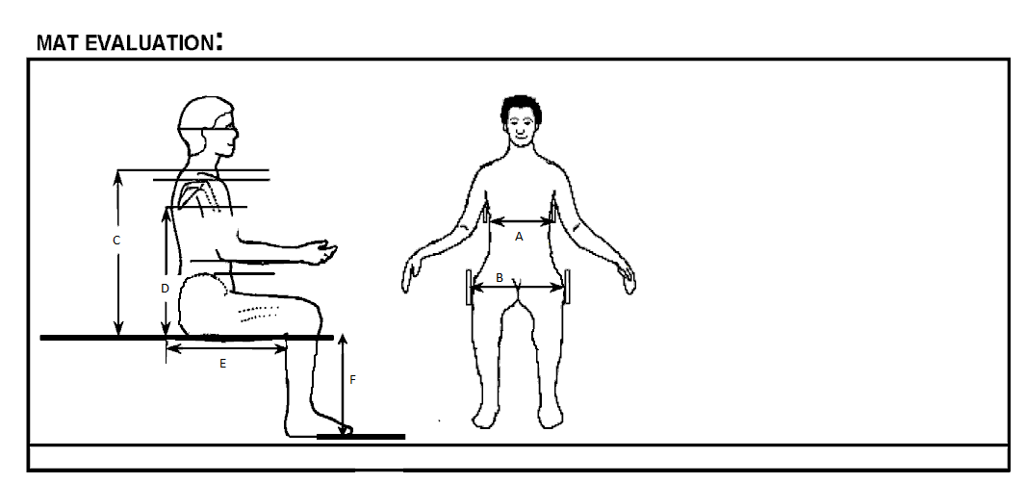

Please provide measurements in inches

A: Chest Width

B: Hip Width

C: Seat to Top of Shoulder

D: Seat to Inferior Angle of Scapula

E: Seat Depth

F: Lower Leg Length

Additional Comments:______________________________________________________________________

________________________________________________________________________________________________________________________________________________________________________________________________________________________________________________________________________________________________________________________________________________________________________

Version: 12-2015

